Assignment/Tutorial/Practical Report Cover Sheet

Assignment/Report Cover Sheet

Student Name | Student Id Number | Signature
RAYME RYAN ANAK ROXY | 106122 | 
DARRYIELL KARLLEN | 103793 | 
MUHAMMAD MARWAN HAKIM BIN ABDUL MALIK | 105252 | 
NUR FATIMA DAMIA BINTI MOHAMMAD YAZIS | 107468 | 

Subject Code: | TMF2954 Sem 2 25/26: Java Programming

Project Title: | G07/MC-G07-ProjectDesign

Due Date: 5 June 2026 | Date Submitted: | 5 June 2026

This cover sheet must be completed, signed and firmly attached to the front of the submission. All work must be submitted by the due date. If an extension of work is granted, an assignment extension acknowledgement slip must be signed by the lecturer/tutor and attached to assignment. Please note that is your responsibility to retain copies of your assignment.

Plagiarism and Collusion are methods of cheating that falls under Peraturan Akademik Universiti Malaysia Sarawak para 11: Etika Akademik

Plagiarism
Plagiarism is the presentation of work which has been copied in whole or in part from another person’s work, or from any other source such as the internet, published books or periodicals without due acknowledgement given in the text.

Collusion
Collusion is the presentation of work that is the result in whole or in part of unauthorized collaboration with another person or persons.

Where there are reasonable grounds for believing that cheating has occurred, the only action that may be taken when plagiarism or collusion is detected is for the staff member not to mark the item of work and to report or refer the matter to the Dean. This may result in work being disallowed and given a fail grade or if the circumstances warrant, the matter may be referred to a Committee of inquiry for investigation. Such investigation may result in the matter being referred to the University Discipline Committee, which has the power to exclude a student.

Upon placing signature above, I certify that I have not plagiarized the work of others or participated in unauthorized collusion when preparing this assignment.

I also certify that I have taken proper case in safeguarding my work and have made all reasonable efforts to ensure that may work not be able to be copied.

MARK :

Table of Contents
Assignment/Tutorial/Practical Report Cover Sheet 1
Assignment/Report Cover Sheet 1
1. Project Overview 3
2. Team Member Role And Contributions 3
3. System Application and Interfaces 5
4. Proof of Testing and Debugging 10
5. Proof of Discussion 13

Project Overview

EduReform 2026 is a desktop-based educational application developed using Java Swing. The system provides educational learning materials, interactive quizzes, gamification features, and score tracking to improve student engagement and learning outcomes.

Team Member Role And Contributions

Name | Student ID | Class Name | Method Implemented | UI Component/Frontend Logic
RAYME RYAN ANAK ROXY | 106122 | EduReformSystem.java  I_AppNavigator.java | createLoginPanel()  createMenuHubPanel()  createSettingsPanel()  createQuizPanel()  showRewardsPanel()  navigateTo()  saveUserScore()  displayLeaderboard()  navigateTo()  saveUserScore()  displayLeaderboard()  exitApplication()  exitApplication() | Main application container using CardLayout. Developed Login Screen, Dashboard Hub, Settings Screen, Navigation System, Leaderboard Screen, Score Storage, and routing between all modules.  Defines navigation, score management, leaderboard, and application lifecycle contracts used by the main system.
NUR FATIMA DAMIA BINTI MOHAMMAD YAZIS | 107468 | EducationModule.java  AssetLoader.java  ContentLoadException.java | loadContentPages()  showPage()  nextPage()  previousPage()  loadImage()  loadContent() | Developed Education Learning Module containing 10 educational pages. Implemented educational text content, image display, page navigation controls, learning progress flow, and return-to-dashboard functionality.  Defines content-loading and image-loading functionality used by the Education Learning Module.
MUHAMMAD MARWAN HAKIM BIN ABDUL MALIK | 105252 | QuizManagerLogic.java  QuizQuestion.java | getPrompt()  getOptions()  getCorrectAnswer()  isCorrectAnswer()  evaluateEngagementRules()  evaluateTimerReward()  updateStreak()  saveUserProgress()  appendProgressToRecordFile()  getLevel()  getTotalPoints()  getAllBadges() | Developed Quiz Module backend. Handles question loading, answer validation, scoring system, question navigation, timer tracking, and quiz progress management. Supports 20 quiz questions.  Represents quiz question objects. Stores question text, answer choices, correct answer, and question type for quiz rendering.
DARRYIELL KARLLEN | 103793 | GamificationHub.java  QuizManagerLogic.java | loadProgress()  checkTime()  answerQuestion()  finishQuiz()  awardBadge()  checkLevelUp()  printEverything()  saveProgress() | Developed Rewards & Gamification Module. Handles points system, badge unlocking, streak tracking, leaderboard rewards, timer bonuses, user achievements, and motivational feedback.  Calculates quiz performance. Generates grades, motivational messages, badges, and score evaluation according to assignment scoring criteria.

System Application and Interfaces

Interfaces | Explanation
Login Screen  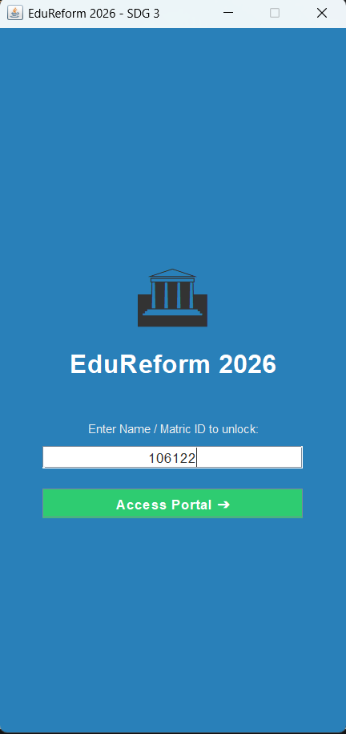 | The Login Screen is the entry point of the application. Users enter their username before accessing the system. The screen validates user input and initializes user data required for quiz tracking, gamification rewards, and leaderboard recording.
Homepage Screen  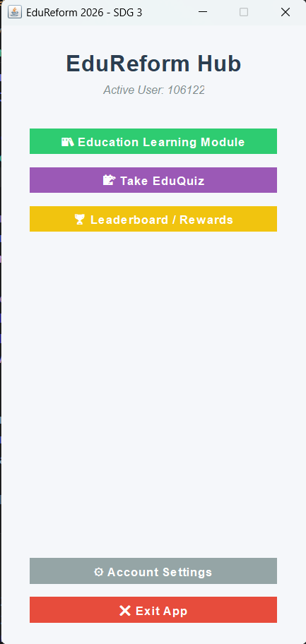 | The Homepage serves as the central navigation hub. Users can access learning materials, quizzes, rewards, leaderboards, and application settings from this screen.
Education Learning Module Page  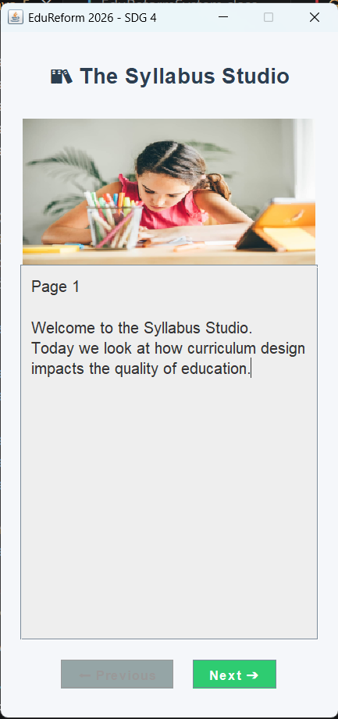  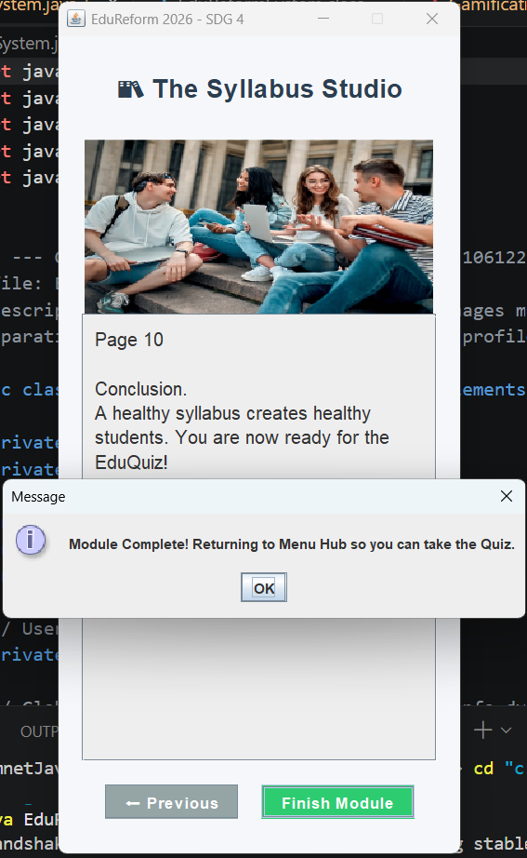 | This module contains ten educational pages related to Sustainable Development Goals (SDGs) that our group has chosen which is SDG 4, Quality Education. Users can navigate between pages using Next and Previous buttons while viewing text and image-based learning content.
Quiz Learning Module  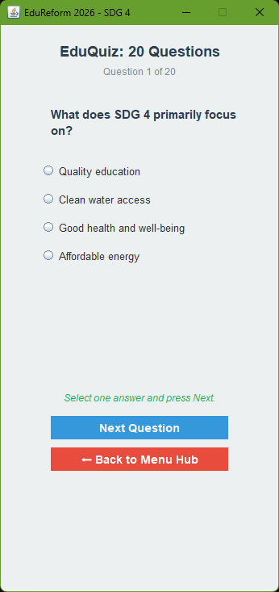  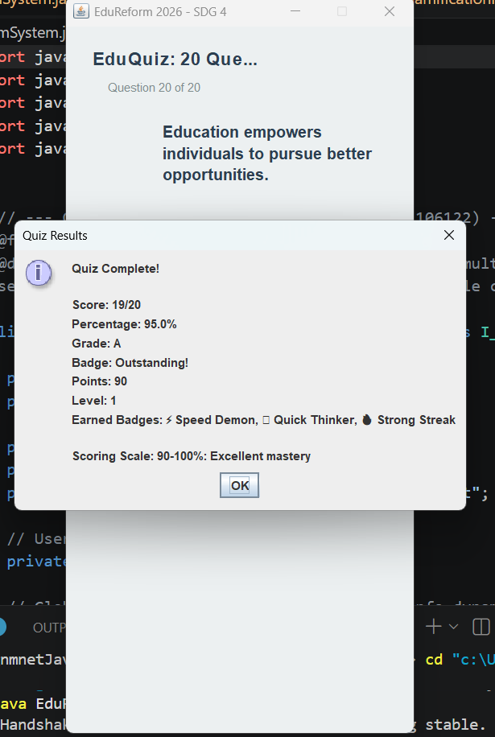 | The Quiz Module contains twenty questions consisting of multiple-choice and true/false formats. The module calculates scores, tracks progress, and displays motivational feedback after completion.
Leaderboard and Gamification Element  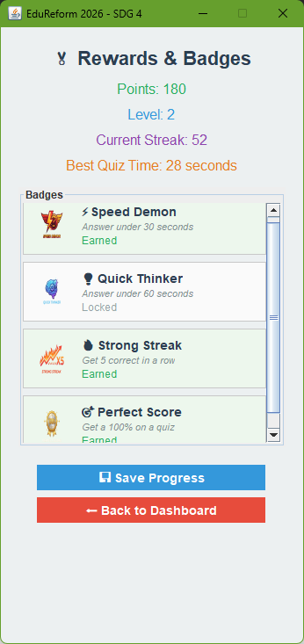 | This module displays user achievements, earned badges, accumulated points, streaks, and leaderboard rankings. It encourages user engagement through reward mechanisms. User progress and scores are stored for future access.
User Profile and Settings  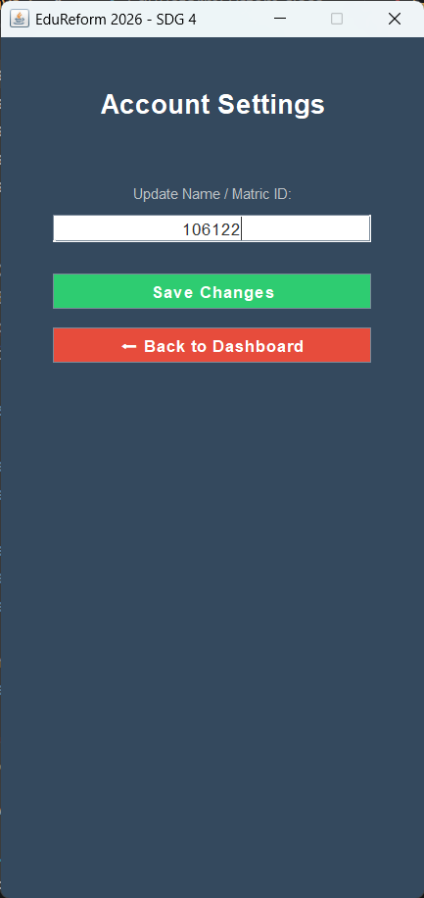  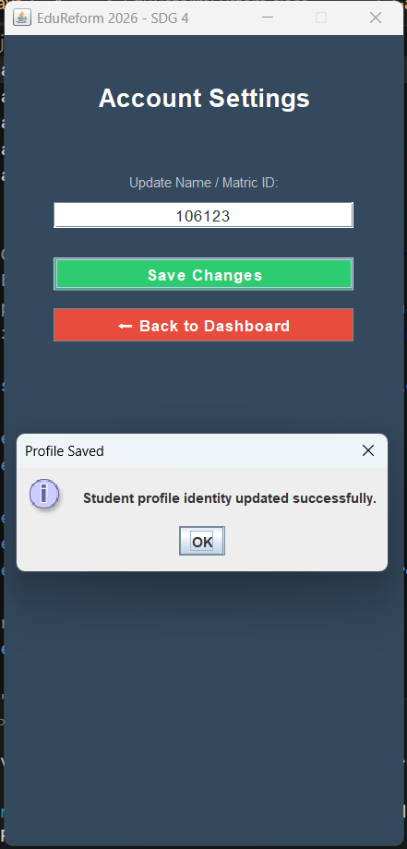  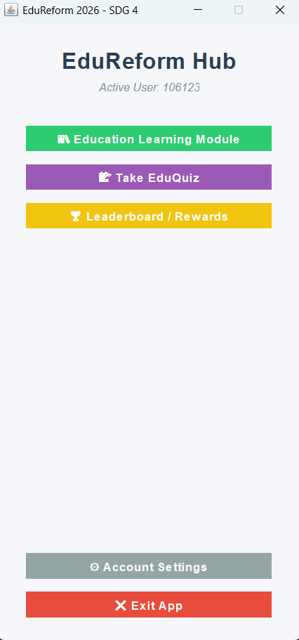 | The Settings module allows users to update their Name/Matric ID which will be changed once the user save the changes.

Proof of Testing and Debugging

Test Case | Expecteed Results | Actual Results | Proof | Status
User Login | User able to enter the main homepage after filling in their student ID | Homepage displayed correctly after entering student ID |  | Pass
Education Navigation | User can move across the module pages | Naviagtion buttons working properly |  | Pass
Score Calculation | Score calculated accurately |  | 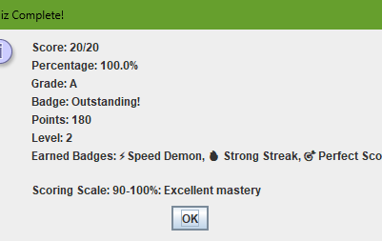 | Pass
  Correct score displayed
Gamification Rewards | Points and badges awarded | Rewards generated correctly | 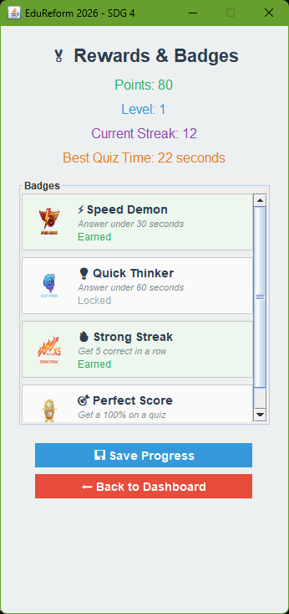 | Pass
Leaderboard Storage | Score saved and retrieved from file | Data stored successfully | 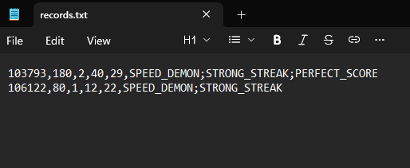 | Pass

Proof of Discussion

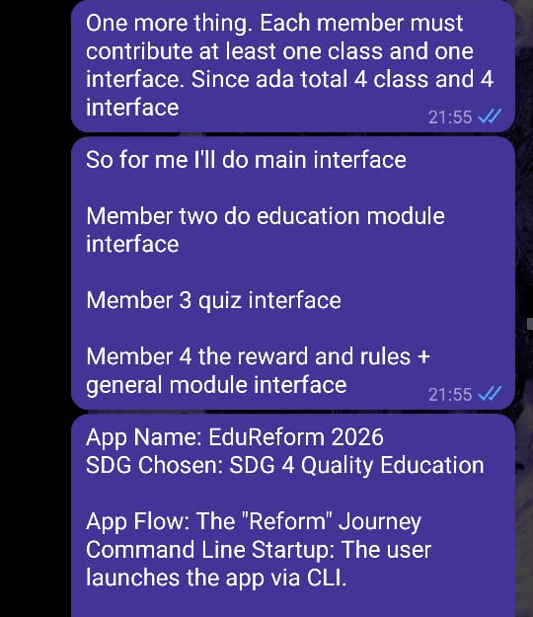 | 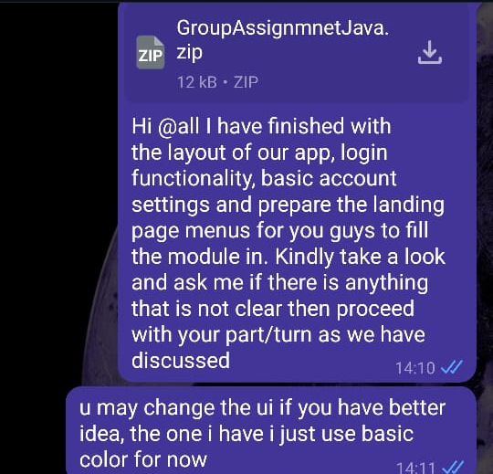 | 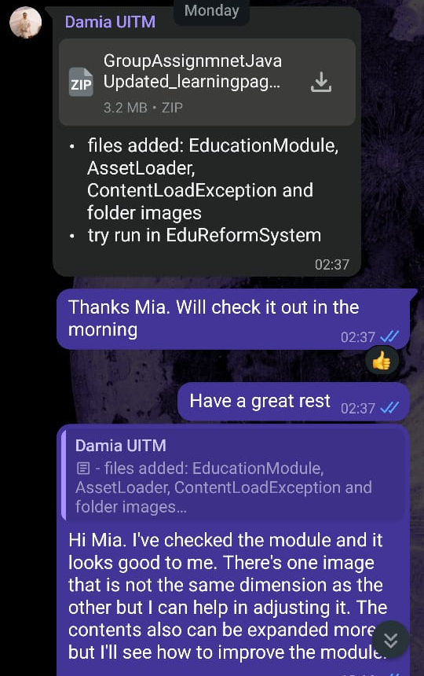
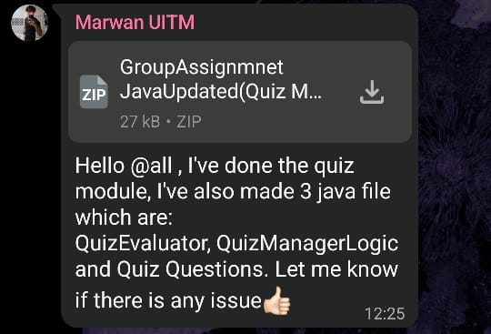 | 

